Health and Physical Education
Grade 3 Study Guide for Nutrition
P.E. Standard: 10.1.3C Explain the role of the food guide pyramid in helping people eat a healthy diet.

DIRECTIONS: Please review the following information with your child for the 10 point quiz next week in Physical Education.

ALL STUDENTS SHOULD UNDERSTAND:
- That the body’s main energy source is carbohydrates.

- The food groups that you should eat the most of everyday are the fruits and vegetables.

- Proteins help to rebuild your muscles.

- The two healthiest meats are chicken and fish.

- Vitamins and Minerals help to maintain normal body functions and systems.

- You get the mineral calcium from the dairy/milk food group.

- Fats are important because they serve as a protector, insulator, and energy source for the body.

- Unused calories will become stored on the body as fat.

- Water is important because it keeps the body hydrated.

- You should drink at least 4-8 glasses of water everyday.

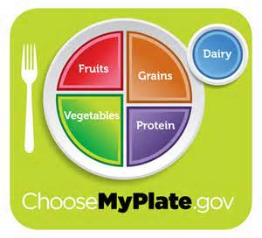

MAKE HEALTHY EASY! 1,2,3,4,5

